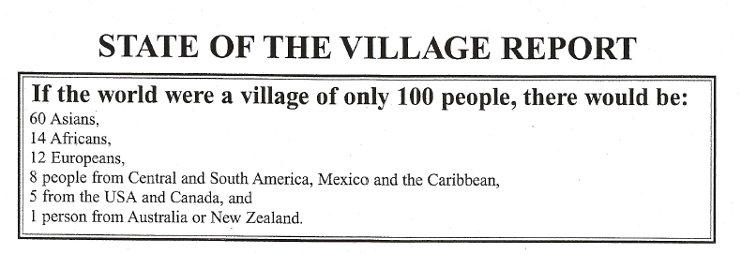

The people of the village would have considerable difficulty communicating:
14 people would speak Mandarin,
8 people would speak Hindi/Urdu,
8 English,
7 Spanish,
4 Russian,
4 Arabic.
This list accounts for less than half the villagers. The others speak (in descending order of frequency) Bengali, Portuguese, Indonesian, Japanese, German, French, and 200 other languages.
In the village there would be:
33 Christians, 22 Moslems, 15 Hindus,
14 Nonreligious, Agnostics, or Atheists, 6 Buddhists, 10 all other religions.
In this 100-person community:
80 would live in substandard housing.
67 adults live in the village; and half of them would be illiterate.
50 would suffer from malnutrition.
33 would not have access to clean, safe drinking water.
24 people would not have any electricity.
Of the 76 that do have electricity, most would use it only for light at night.
In the village would be 42 radios, 24 televisions, 14 telephones, and 7 computers
(some villagers own more than one of each). 7 people would own an automobile (some of them more than one).
5 people would possess 32% of the entire village's wealth, and these would all be from the USA. The poorest one-third of the people would receive only 3% of the income of the village.
The following is also something to ponder...
If you woke up this morning healthy ... you are more blessed than the million who will not survive this week.

If you have never experienced the danger of battle, the fear and loneliness of imprisonment, the agony of torture,
or the pain of starvation ... you are better off than 500 million people in the world.

If you have food in the refrigerator, clothes on your back, a roof overhead and a place to sleep ...
you are more comfortable than 75% of the people in this world.

If you have money in the bank, in your wallet, and spare change in a dish someplace ...
you are among the top 8% of the world's wealthy.

If you can read this, you are more blessed than over two billion people in the world who cannot read at all.
When one considers our world from such a compressed perspective, it becomes both evident and vital that education, acceptance and compassion are essential for the progress of humankind.
This material is copyright-free. You may reproduce it. Original version by Donella H. Meadows

